**LAB PRACTICAL DAY 11**

1. Bellman Ford algorithm

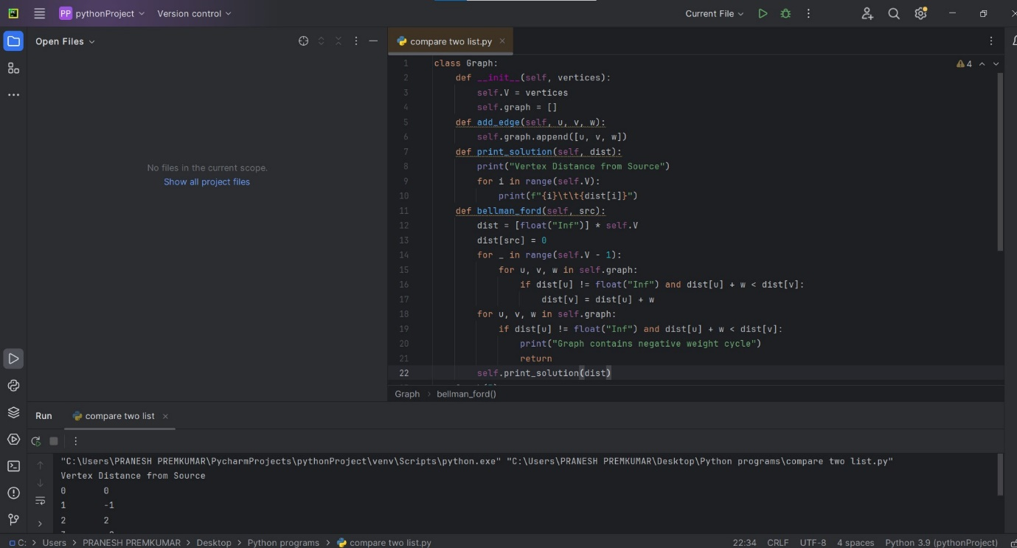

2.Warshalls algorithm

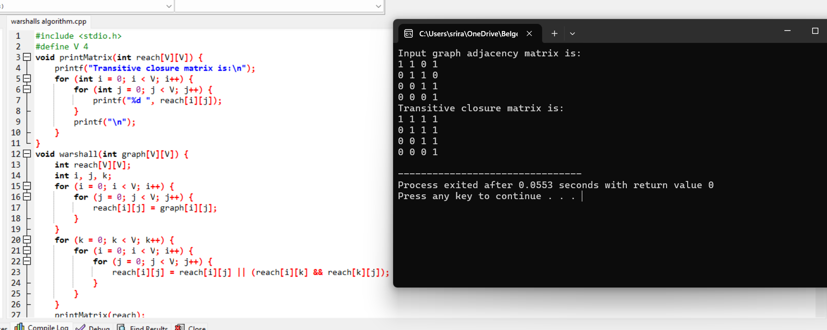

3.Coin change problem

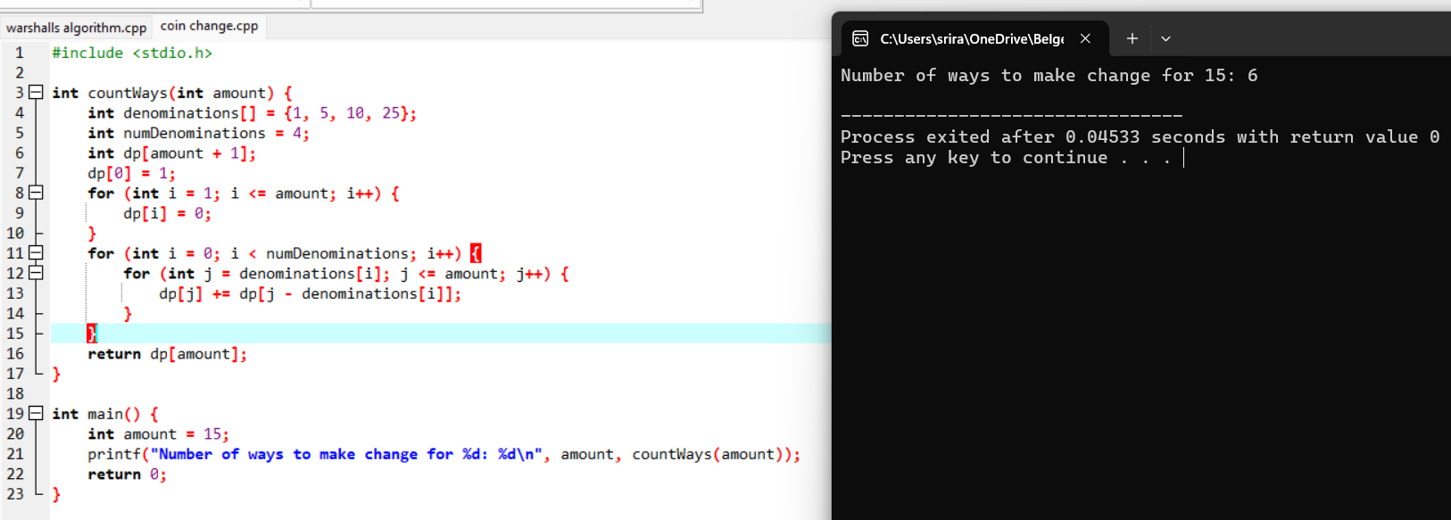

4.Knapsack problem using greedy

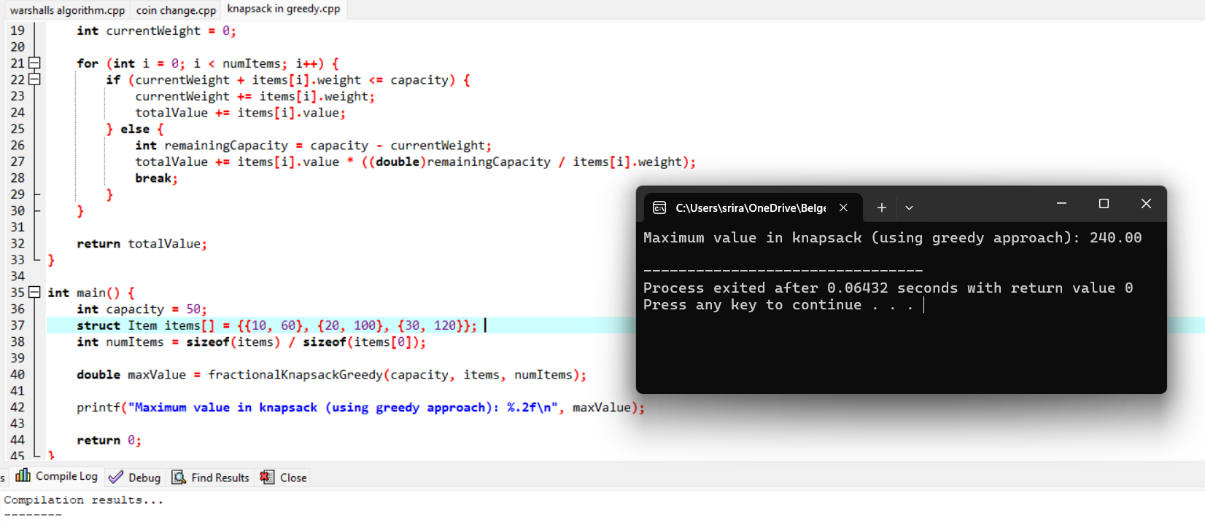

5.Job sequence with deadlines

